IQService Installation on both TLS and non TLS steps
Step 1: Download the IQService zip in the Sailpoint folder.
Step 2:open command prompt in Sailpoint/Iqservice as an adminisrataor
Step 3: IQService.exe -i -p 5050 -o 5060 ==command to install IQServece using TLS and Non Tls
Here 5050 will be the non TLS and 5060 will be the TLS
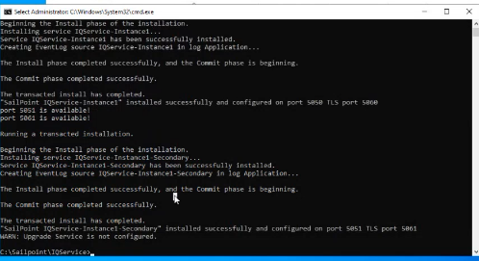
IQService.exe -v == to get version information
IQService.exe -s== to start the IQService
After this we are going to use the update command , when ever there is any update patch it should be go from the VA to IQService.
IQService.exe -z "tcps://localhost:5062" == we are doing it on 5062
Now we have to restart the IQService
IQService.exe -t
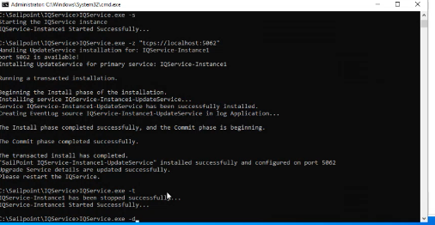
Again we can check the update service
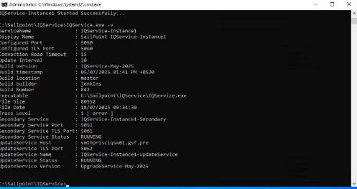
The Installation part is done.
Next we need to check for the TLS part the IQService certs also placed on the VA
For that we need to go to AD IQServices in the UI
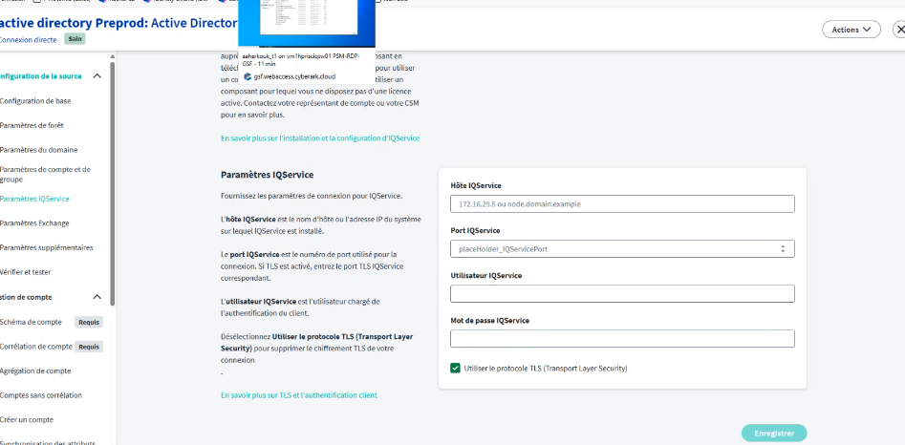
Need to provide IQService host name:
To get the command needs to be run in IQService cmd:set
In that get the computername. And also inclide the domain name aswell like below screenshot
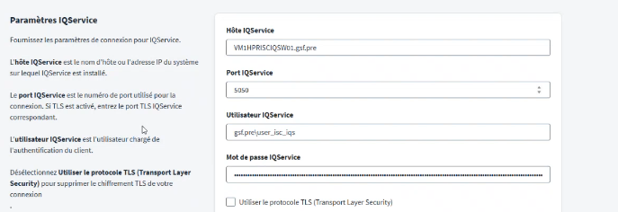
And the port should be 5050 for the non tls
Go to the registry in windows search bar search for the registry
Go to HKEY_Local_Michine
Expand the HKEY_LOCAL_MACHINE
SAILPOINT

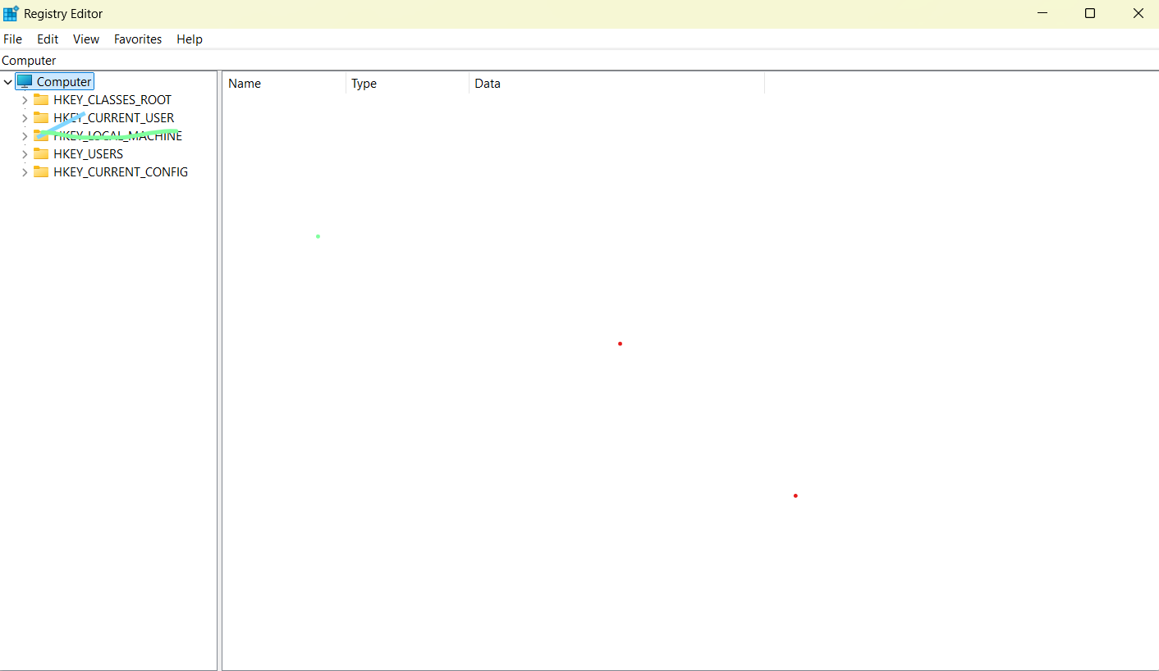
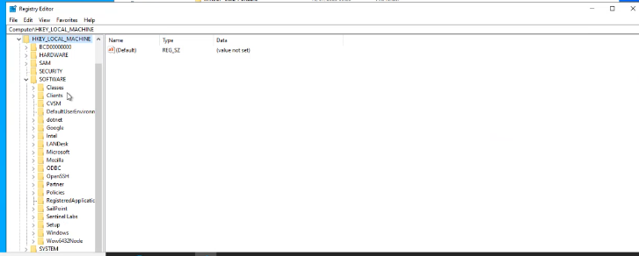
Expand the Sailpoint folder
right click on that IQ service instance, the first one.
Go to permissions
Your can you add that service account that you'll be utilising for the?
IQ service connectivity.
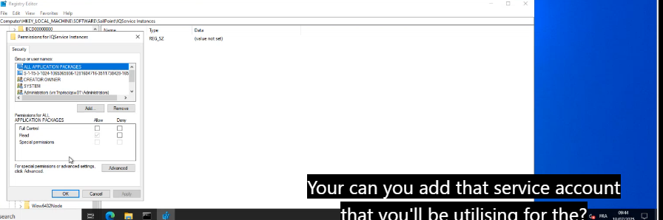

IQ The the the account. The service account that you'll be utilising on the UI. You'll be putting one service account right for that you would have created on AD for the IQ service specifically.
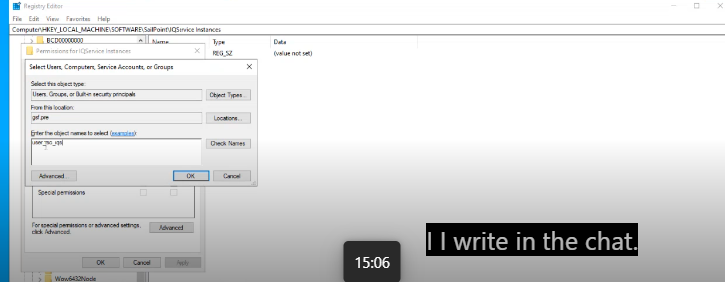
Check names
Ok
Give full control after select the user
Ok
Close this registry
Go to services
Yeah. So you point IQ, so instance one, right, right click on that instance 1.
Go to properties.
Go to log on.

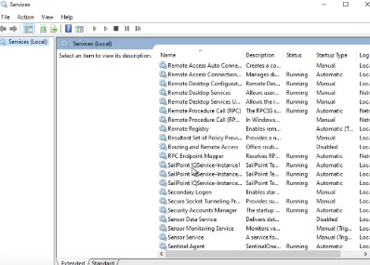
his account select the second option. This account browse for the same service account that Nicholas just said, right? Just browse for that account.
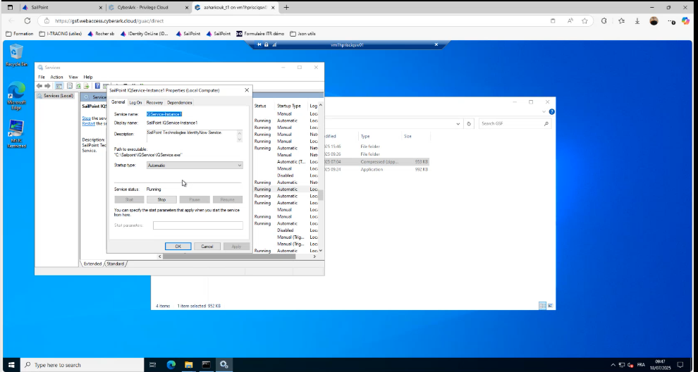
In logon =From the location =should select choose the domain name yes location entire directory.
here you need to enter the password and confirm the password for the service account and give an apply.
Click on ok
Go to command prompt
Restart the IQService
IQService.exe -t
Next to see the list of users
IQService.exe -a list
IQService.exe -a abc\sailpoint
you need to give the username that is the service account name in the domain slash service account format.
IQService.exe -a <Domain User/s> --here s means service account

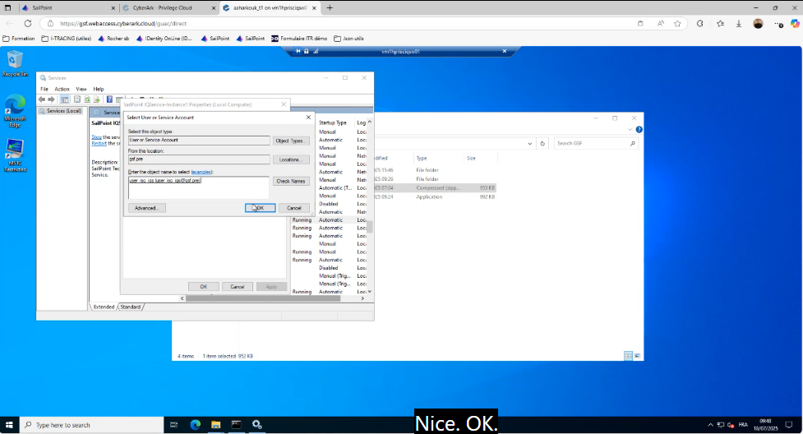we are set now we have added the IQ service instance with the service account. We're gonna utilise here and we've given the service account the complete permissions also. So you can give the username password here.
And I believe even in the OK just say for now we'll see if this works. If not, we'll give it as domain name slash.
In the IQService username we should give the service account name in the same format where we mentioned in the IQService users list
to add to make it TLS. Right, we need to have the IQ service cert in the VA.
You need to go to the VA machine. The virtual appliance machine
I'm just putting a command and open SSL command for you to see if it is picking up the cert from the IQ service mission.
openssl s_client -connect IQSvc.hostname:5060 –showcerts
IQSvc.hostname-----hostname of IQService
so you just have to copy the certificate from the begin certificate space and that line end certificate yes.
u will have to put it on the same BA only you have to create a cert file on the go to CD home /salepoints/Cert I believe.
Create a certificate file name
Vi filename.cer
CTRL+G to get bavk to the vi page
Example command :Vi iq.cer
Enter I to insert
Use the I command for inserting the value and then do a right click. I don't know how paste works here, but yeah, yeah, perfect escape WQ.
Now do a ls
Now we have the certs in place .
We need to restart the VA using sudo reboot
So yeah, it will close down the VA, give it a minute and then you can reopen the VA.
we are good. Can you go to the UI and try to change the PLS port to 5060?
And yeah.
Now save it and then do a test.
OK, that's it. We are good then and if you want to troubleshoot anything on the IQ services, you do have a log folder that gets accumulated in the same folder. Or if you wanna increase like you wanna debug something. In that case I have another command which I'll share.
Go on the IQ service Windows machine.
Go to the IQ service folder. The sale point folder.
go into this instance 1.

Here we can find the IQServicetace.log in sailpoint fplder.
The test connection? Yeah, that's what I'm saying. The the log level is not in. It's just an info level. So if you wanna increase it to a debug level then you will have to change it from. I think you'll have 1-2 and three. Three. You can either use it. One is more of a info.

